Associate Exit Flow

*(Associate Exit Flow – Guide)*

This document describes in detail the **Associate Exit Flow**. This portal has different user roles like (*Associate, Program Manager, HRM- Human Resource Manager, HRA, Team Lead, Manager-IT department, Manager-Admin department, Manager-Finance department, Manager-Training department).*

**HRA**

1. Once HRM approves the resignation. HRA can initiate activities
2. HRA needs to Login into the portal (Via single sign-on) with SenecaGlobal email Id. After authentication,

HRA will be redirected to the Dashboard page. HRA needs to click on the Associate Exit section and an ‘**Exit-Action’** module.

1. Can initiate the exit activities and Parallelly Exit Interview, KT plan actions can also be done
2. Can view the status as “Resignation In progress”
3. An email will trigger to respective service departments
4. To view all the checklists, click on “View” button. By default, all check list status is displayed in colour “Red”.

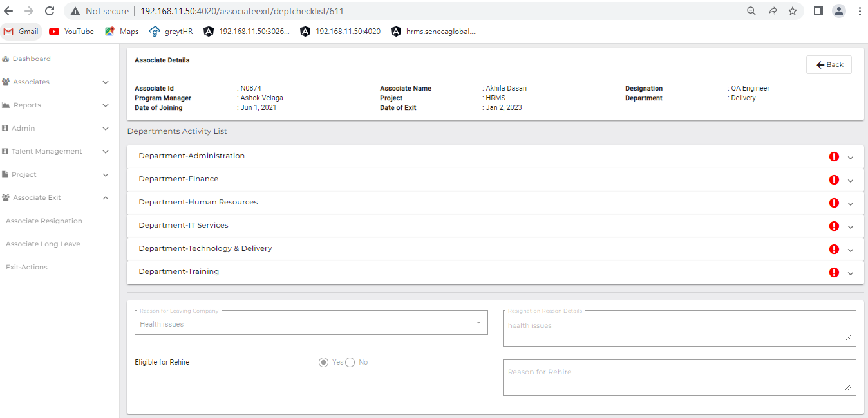

1. Department list

* Administration
* Finance
* Human Resource
* IT Services
* Training department

1. An email notification is triggered to all the above-mentioned Departments.

Department wise check list.

1. **IT Department**
   1. IT Manager needs to Login into the portal (Via single sign-on) with SenecaGlobal email Id. After authentication, IT manager will be redirected to the Dashboard page. They need to click on the Associate Exit section and Exit-Action module to view '**Pending Request.'**
   2. Now the System will display Associates details who are resigning with status as '**Resignation InProgress'** for IT Department.
   3. Clicking on **Approve Checklist** Button navigates to Associate Exit Check List screen

* Below checklist activities need to be submitted:
* **Handover of Assets:**
* Desktop**/**Laptop
* Other devices (Tablet PC, iPhone, iPad…)
* Mobile phone
* Data card
* Headphones
* Client Hardware Assets
* Client Software Assets
* Removal of client VPN and any other access
* Backup of system, Data and email
* Others
* **Removal of Access, Privilege, Benefit:**
* Deactivation and Removal of active directory user credential
* Deactivate Jira and Removal of Bit Bucket/TFS
* Removal of Email access
* Removal of Conferencing account access
* Removal of Internet Access
* Others
  1. Clicking on Save button saves it as a Draft.
  2. **Once submitted, the clearance and IT Department will issue the NOC, and notifies the Associate and HRM Head, as the Status is updated to 'Completed'.**
  3. The Particular Associate’s data can view read-only mode by clicking on view (eye icon) on IT Manager's Exit-Action Screen.

1. **Admin Manager**
2. Admin Manager needs to Login into the portal (Via single sign-on) with SenecaGlobal email Id. After authentication, Admin manager will be redirected to the Dashboard page. They need to click on the Associate Exit section and Exit-Action module to view '**Pending Request.'**
3. The system will display the Associate details who are resigning with the status '**Resignation InProgress'** for Admin Department.
4. Clicking on ‘**Approve Checklist’** Button navigates to ‘**Associate Exit Check List’** screen.
5. Admin Department must submit below checklist activities

* **Handover of Assets:**
* Stationery items
* Desk/cabin keys
* Library books
* Associate ID card
* Others
* **Removal of Access, Privilege, Benefit:**
* Deactivation of office entry access card and biometric attendance entry
* Others

1. Clicking on Save button saves it as a draft.

* **If Admin issues NOC clearance, the Associate and HRM Leader are notified, and Status is updated to 'Completed'.**

1. The Particular Associate’s data can view read-only mode by clicking on view (eye icon) on Admin manager Exit-Actions Screen.
2. **Finance Department**
3. Finance team needs to Login into the portal (Via single sign-on) with SenecaGlobal email Id. After authentication, team will be redirected to the Dashboard page. They need to click on the Associate Exit section and Exit-Action module to view '**Pending Request.'**
4. The system will display the Associate details who are resigning with status '**Resignation InProgress'** for Finance Department.
5. Clicking on ‘**Approve**’, Checklist Button navigates to the ‘**Associate Exit Check List’** screen.
6. Finance Department needs to submit below checklist activities:

* **Income Tax Compliance:**
* Submission of Income tax declaration documents for tax exemption
* Submission of SGBP proof documents for tax exemption
* Others
* **Amount to be Recovered from Associate:**
* Income Tax
* Travel advance
* Others

1. Clicking on Save button will save it as a draft.
2. **When Finance Department issues the NOC, it is notified to the Associate and HRM Leader, and the Status is updated to ‘Completed’.**
3. The Particular Associate’s data can view read only mode by clicking on view (eye icon) on Finance Exit-Actions Screen.
4. **Human Resource**
5. HRM needs to Login into the portal (Via single sign-on) with SenecaGlobal email Id. After authentication, HRM will be redirected to the Dashboard page. They need to click on the Associate Exit section and Exit-Action module to view 'Pending Request'.
6. The System will display Associate details who are resigning with status as ‘Resignation InProgress’ for HRM department.
7. Clicking on ‘Approve Checklist’ Button navigates to ‘Associate Exit Check List’ screen.
8. HR Department must submit the below checklist activities:

* **Handover of Assets:**
* Deactivation/Removal of access to Greytip
* Medical insurance
* Group gratuity
* Accident insurance
* Meal card/Multi wallet card
* Provident fund
* **Amount to be Recovered from Associate:**
* Notice Period Buyout Amount
* Relocation Expenses
* Joining Bonus
* Salary Advance
* Excess Salary Paid
* Others

1. Clicking on Save button saves it as a draft.
2. **When HRM issues the NOC, the Associate and HRM HR Leader are notified, and the status is updated to ‘Completed’.**
3. The Particular Associate’s data can view read-only mode by clicking on view (eye icon) on HRM Screen.
4. **Training Department**
5. The training team needs to login to the portal (Via single sign-on) with SenecaGlobal email Id. After authentication, Training department will be redirected to the Dashboard page. They need to click on Associate Exit section and Exit-Action module to view ‘Pending Request’.
6. System will display Associate details of associates who are resigning with status as ‘**Resignation InProgress’** for Training Department.
7. Clicking on ‘**Approve**’ Checklist Button navigates to ‘**Associate Exit Check List’** screen.
8. Training department needs to submit the below checklist activities:

* **Handover of Assets:**
* Training kits
* Others
* **Removal of Access, Privilege, Benefit:**
* Access to training websites
* Others

1. Clicking on Save button saves it as a draft.
2. **If Technology & Delivery Manager issues NOC clearance, the Associate and HRM Leader are notified, and Status is updated to ‘Completed’**
3. The Particular Associate’s data can view read-only mode by clicking on view (eye icon) on Training department Dashboard.